BASKETBALL WRITTEN TASK Name: _______________________
- Name the following dribbling violations:
- Dribbling with two hands at the same time _______________________ .
- Dribbling then you grab the ball and then dribble again ____________________ .
- How do you start a game? _________________ .
- If you make a shot from behind the three point line, how many points is it worth? _____.
- If you make a shot from inside the three point line, how many points is it worth? ______.
- What is it called if you take more than two steps without dribbling the ball? __________.
- How many points is a free throw worth? ______________ .
- If you are fouled while shooting a three point shot and the ball does not go in, how many free throws do you get? __________________ .
- What is it called if you jump up with the ball in your hands and come down with it without letting go? ___________________.

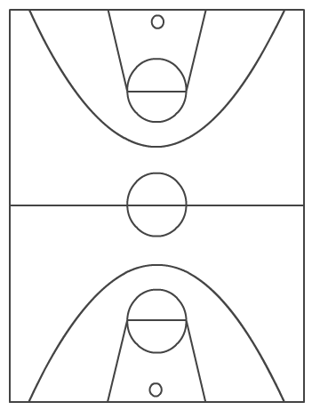
Name the following:

a) __________________

b) __________________

c) __________________

d) __________________

e) __________________(area)

f) __________________

