Name :
Swimming Assessment
Directions: Please return competed by next class for full credit.
- Name three strokes and their cues for each stroke that was learned in class?
1.
2.
3.
2. What are three key notes for lifeguarding?
1.
2.
3.
3. Name the emergency procedures you learned during class?
1.
2.
3.
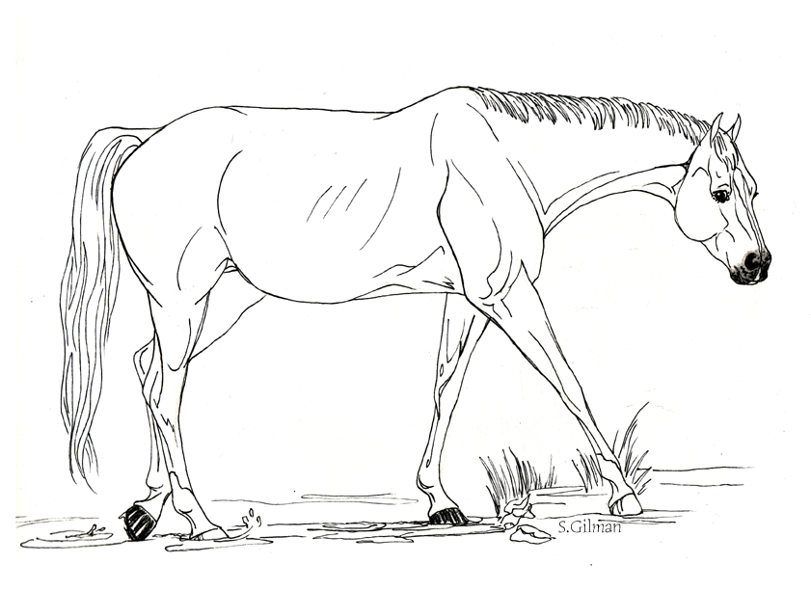
4. Look at the picture, what is rule # 3?

