Name :
Swimming Assessment
Directions: Please return competed by next class for full credit.
- What are the three areas of learning in Mr.K’s PE class?
1.
2.
3.
2. What are three key elements to breathing while swimming?
1.
2.
3.
3. Name the three strokes that we covered during class.
1.
2.
3.
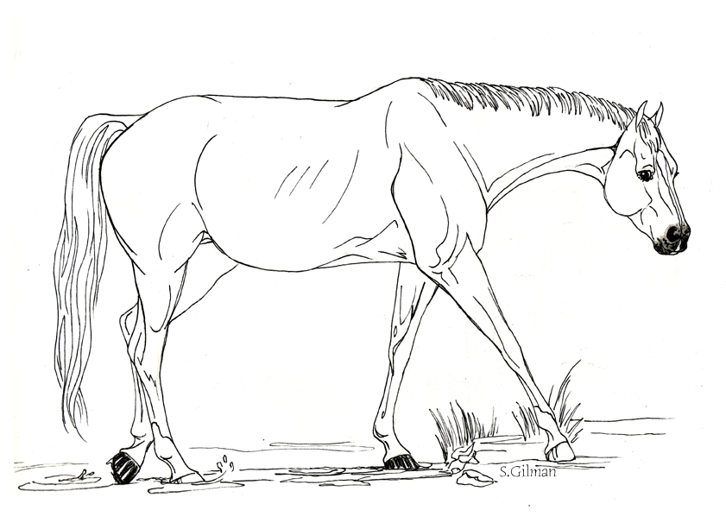
4. Look at the picture, what is rule # 3?

