***RATE YOUR FOOTBALL KNOWLEDGE***

1. Are you able to explain the terms listed below in your own words?
2. Goal kick. b) Corner kick. c) Penalty shot. d) Direct free kick. e) Indirect free kick. f) Yellow card. g) Red card. **7 Points**
3. Can you label the following on the diagram below?
4. Two sidelines. b) Two end lines. c) Two penalty spots. d) Two penalty boxes. e) Midfield line. f) Basic positions: (i) Goalie. (ii) Defenders. (iii) Midfielders. (iv) Forwards.

**13 Points**

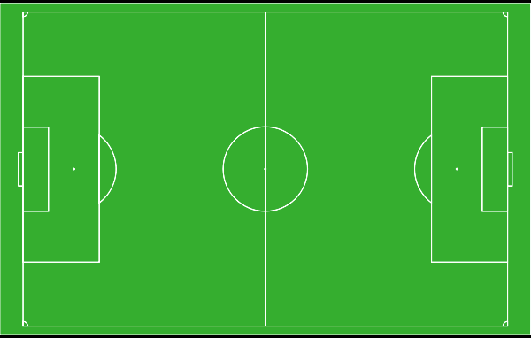

C:\Users\qiss\AppData\Local\Microsoft\Windows\Temporary Internet Files\Content.IE5\YYE860U0\MC900383572[1].wmf C:\Users\qiss\AppData\Local\Microsoft\Windows\Temporary Internet Files\Content.IE5\YYE860U0\MC900383572[1].wmf

C:\Users\qiss\AppData\Local\Microsoft\Windows\Temporary Internet Files\Content.IE5\YYE860U0\MC900383572[1].wmf

C:\Users\qiss\AppData\Local\Microsoft\Windows\Temporary Internet Files\Content.IE5\YYE860U0\MC900383572[1].wmf C:\Users\qiss\AppData\Local\Microsoft\Windows\Temporary Internet Files\Content.IE5\YYE860U0\MC900383572[1].wmf

C:\Users\qiss\AppData\Local\Microsoft\Windows\Temporary Internet Files\Content.IE5\YYE860U0\MC900383572[1].wmf

C:\Users\qiss\AppData\Local\Microsoft\Windows\Temporary Internet Files\Content.IE5\YYE860U0\MC900383572[1].wmf C:\Users\qiss\AppData\Local\Microsoft\Windows\Temporary Internet Files\Content.IE5\YYE860U0\MC900383572[1].wmf

C:\Users\qiss\AppData\Local\Microsoft\Windows\Temporary Internet Files\Content.IE5\YYE860U0\MC900383572[1].wmf

C:\Users\qiss\AppData\Local\Microsoft\Windows\Temporary Internet Files\Content.IE5\YYE860U0\MC900383572[1].wmf C:\Users\qiss\AppData\Local\Microsoft\Windows\Temporary Internet Files\Content.IE5\YYE860U0\MC900383572[1].wmf

C:\Users\qiss\AppData\Local\Microsoft\Windows\Temporary Internet Files\Content.IE5\YYE860U0\MC900383572[1].wmf = Players on same team attacking from left to right

**WHAT IS YOUR SCORE OUT OF 20 POINTS?**